



Luigi Galvani
(Silvio Bergia)
Luigi Galvani (Bologna, 9 Sept. 1737 – Bologna 4 Dec. 1798) received his degree in medicine and philosophy on 15 July 1759. On 26 February 1782 he was appointed professor of obstetric arts at the Istituto delle Scienze.
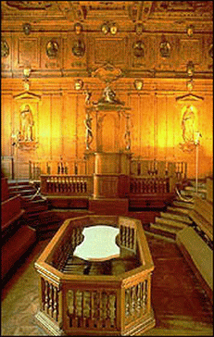 | Fig. 1: The anatomical theatre of the Archiginnasio where Galvani operated.
The studies for which Galvani is best known concern so-called animal electricity.
The Swiss physiologist Albrecht von Haller (1708-1777) had shown that a stimulus directly applied to a nerve caused a sharp contraction of the muscle to which it was connected. In Italy, especially in Bologna, due to the influence of authors such as Giovanni Battista Beccaria (Mondovì, 1716 – Turin 1781), scientists particularly pursued investigations into the effects of electricity on animate beings. Galvani was also influenced by the studies carried out by Marcello Malpighi.
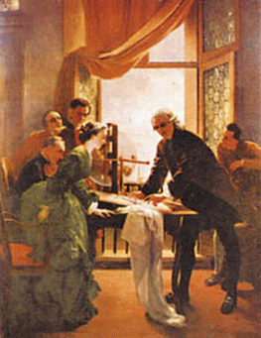  Fig. 2: Galvani carries out one of his experiments in the presence of his wife and some assistants. The painting is preserved in the premises of the University of Bologna.  (Credit: Quadreria dell'Università degli Studi di Bologna) |  | From 1770??? onwards, Galvani performed a series of experiments to investigate the reactions of duly prepared frogs to electric stimulations. As a first stage, the aim was to observe the contractions to which the frog’s muscles were subjected when directly touched by the conductor of an electrostatic generator.  An important turning point took place when he had the impression that similar contractions occurred in a muscle of a frog that an assistant was touching with an uncharged conductor while, by mere chance, another assistant had extracted a spark from the conductor of an electrostatic generator by drawing a conductor close to it. Puzzled by the phenomenon, Galvani carried out a series of experiments that confirmed the effect.

 | (Luigi Galvani - page 1 of 4)  | Forward >

The Webweavers: Last modified 11/26/2004 21:21:20





Luigi Galvani (continued)
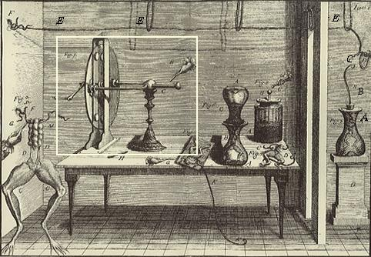
Fig. 3: Illustration of the experiment showing the excitation at a distance of the crural nerve of a frog as the effect of a spark released by the conductor of an electrostatic generator. The conductor, as well as the stick carrying the conductor employed to extract the spark from the machine, can be seen on the left. Note the metallic cable E drawn across the room - it is isolated by letting it hang from silk knots: at one of the ends was hanging the hook B, communicating through a metallic wire with the crural nerves of a frog, kept in the glass container A. The frog’s legs were in contact with a conducting material, in this case lead shot.
(Credit: Dall'opera "De viribus electricitatis in motu musculari commentarius")
The experimental set-up used by Galvani in these experiments closely resembles modern radio-telegraphic transmitting-receiving apparatus: the discharges produced by the machine are generically oscillating; they generated radio waves that, propagating, generated in turn high frequency currents in the wire E, which worked as the antenna of the receiving apparatus. The crural nerves of the frog operated as a detector, the lead shot as ground. The interpretation of the experiments in these terms is, however, recent: before the theoretical and experimental studies carried out by Maxwell and Hertz towards the end of the twentieth century, it could not be conceived of by either Galvani or any others who learned about them.
In those days it was not generally agreed that "artificial electricity" (that produced and studied in a laboratory) and atmospheric electricity (which manifests itself, for instance, in terms of flashes of lightning), were of the same nature. "After arriving at the discoveries expounded until now regarding the force of artificial electricity in muscular contractions – wrote Galvani – it was our wish to investigate whether so-called atmospheric electricity could produce, or not, the same phenomena: that is to say, whether, following the same devices, the discharge of lightning would produce muscular contractions like those produced by the spark". He then carried out some experiments to reveal the possible effects.
(Luigi Galvani - page 2 of 4)
< Back | | Forward >

The Webweavers: Last modified 11/26/2004 21:22:51




Luigi Galvani (continued)
Let’s read the description that Galvani gave of one of his experiments:
"The experiment was successful, according to our expectations, exactly as in the case of artificial electricity: each time a lightning was seen, in that very instant all muscles underwent violent and numerous contractions, in such a way that, just as the flashes of lightning are used to anticipate the thunder and, as one may say, almost pre-announce it, in the same way the movements and muscular contractions of those animals; more than that, the manifestation of the phenomena was so impressive that the contractions took place even if the conductor was not applied to the muscles and the conductors of the nerves were not isolated; furthermore, beyond any hope and expectation, the same facts were observed with the the conductor being placed even at lower positions, mostly if the flashes of lightning were powerful and came from clouds near to the site of the experiments, or if someone held the cable (F) in his hands at the moment when the flashes were emitted."
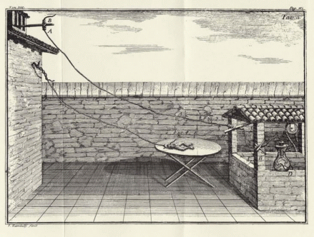
Fig. 4: Illustration of the experiment through which Galvani showed that the nerve of the frog was excited by an electric atmospheric discharge detected by his receiver. In this case it is the (isolated) wire hanging from A that works as an antenna. The frog contained in the vessel D is connected to it. To its extremity is connected another conductor that ends in the water of a well.
(Credit: Dall'opera "De viribus electricitatis in motu musculari commentarius")
In this case the experimental apparatus corresponds even more closely to a receiving radio-telegraphic device, while the emitting role is played by nature. The character of transmission at a distance is much more evident. The Galvanian antenna derives from the metallic wires used by Benjamin Franklin in order "to capture atmospheric electricity" and from the lightning rod.
Later on Galvani discovered that the muscular contractions took place also when, once the frog was lying on an iron plate, a brass hook was pushed against it. Contractions appeared to depend on the metal used. In a series of experiments, in which the same effects were manifested, Galvani used metallic arcs, one of whose extremities was put in contact with the brass hook, which in turn was put in contact with the spinal marrow, the other with the muscles of a leg. How should this result be interpreted?
Galvani made the hypothesis of an "electricity intrinsic in the animal", which, put in circle by the external bimetallic arc, produced the contraction of the muscles. For him, the frog's muscle, besides being an extremely sensitive detector, was thus also a "container" of electricity.
All these results were expounded by Galvani in his work De viribus electricitatis in motu musculari commentarius, published in 1791. This is a wonderful piece of work, of great scientific value and also easy to understand.
(Luigi Galvani - page 3 of 4)
< Back | | Forward >

The Webweavers: Last modified 11/26/2004 21:23:48




Luigi Galvani (continued)
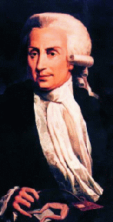 |  | 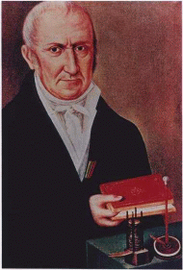
Fig. 5: Portrait of Luigi Galvani. |  | Fig. 6: Portrait of Alessandro Volta.
Alessandro Volta, at the University of Pavia since 1778, was struck by Galvani's work and repeated his experiments. However, he soon reached quite a diverging interpretation: the contractions of the frog's muscles are not due to an animal electricity, but to the irritation of the nerves produced by the electric fluid (not of animal origin) put in motion by the bimetallic contact. The frog, in conclusion, was not a container of electricity, but only a detector.
A debite then began between the two authors and their collaborators, which led to a deepened understanding on both sides. A short term product of paramount importance can be credited to Volta, who first discovered the contact potential and later invented the pile (1800).
A consequence of this success was that for quite a long time a silence fell over those results of Galvani's that had to do with animal electricity. It should not be forgotten that he had shown, in 1794, that the contractions of the frog's muscles could take place using a monometallic arc, or even (1797) establishing a contact between the crural nerves and the muscles of the frog's legs. He later performed a final experiment (described in a letter to Lazzaro Spallanzani, and considered by the German physiologist Emil Du Bois Reymond as the basic experiment of electrophysiology), where contact was established only between the crural nerves of two frogs’ thighs, thus also eliminating the heterogeneity of the tissues.
It was in fact Du Boys Reymond, in 1848, who gave rise to a revival of Galvani's work, stating that, after half a century, animal electricity should claim the place that it deserved. In Italy, Galvanian studies were taken up again by, amongst others, Leopoldo Nobili and Carlo Matteucci.
In 1796 Napoleon's army occupied Bologna. Galvani refused to swear allegiance to the Cisalpine Republic. That cost him the loss of the positions he occupied at the University and The Institute of Science. He was reinstated as emeritus professor only after his death in 1798.
Check out the following website for a series of activities organised to celebrate the bicentenary of Galvani’s death: http://www.bo.infn.it/galvani/.
Useful links
Celebrations for the bicentenary of Luigi Galvani’s death:: The panels of the Galvani-Volta exhibition, Two hundred years young (W.Tega)
(Luigi Galvani - page 4 of 4)
< Back |

The Webweavers: Last modified 11/26/2004 21:24:46

